

Council Office, 122 Sea Road, East Preston, West Sussex. BN16 1NN

Tel: 01903 770050 www.arun.gov.uk/eastpreston Email: [epparishcouncil@btconnect.com](mailto:epparishcouncil@btconnect.com)

**AMENITIES COMMITTEE**

|  |  |
| --- | --- |
| **MINUTES:** | of the Proceedings of the Meeting of the Amenities Committee held on 8th August 2022 at 19.00, at East Preston Infant School, Lashmar Road, East Preston. |
| **PRESENT:** | Councillor S Wilkinson (Chairman), Councillor’s S Toney, R McElroy, E Linton D Moore, B Gale,  and K Bradshaw. |
| **ALSO:** | Dawn Reid (Assistant Clerk to the Council)  Simon Cross (Clerk to the Council)  Alan Hultquist (Chairman, Disability Action Group of East Preston (DAG)  Richard Akhurst (Vice-Chairman, Disability Action Group of East Preston (DAG)  Kelvan Gale |
| **APOLOGIES:** v | Councillor C Bowman (Holiday) |

_____________________________________________________________________________________

As everyone attending the meeting was present, the Chairman opened the meeting at 18:55.

**697/22 INTRODUCTIONS**

Cllr Wilkinson welcomed all those present. Introductions were given.

**698/22 APOLOGIES AND REASONS FOR ABSENCE**

Apologies were received and accepted from Councillor C Bowman

**699/22 PUBLIC QUESTION TIME**

As members of the public were present to discuss item 7b: Public Toilets Sea Road - To consider concerns raised by the Disabled Action Group of East Preston (DAG), regarding access problems to the Hoist Assisted Toilet (HAT), the Chairman brought this item forward in the Agenda for discussion.

The committee noted the report which was circulated prior to the meeting.

Committee has received correspondence from Mr Alan Hultquist, DAG (Disabled Action Group) Chairman, outlining the groups concerns relating to problems encountered accessing the Hoist-Assisted Toilet (HAT). DAG suggested the following improvements could be made to address these issues:

1. An electric sliding door would improve access, especially for someone using the facility on their own.
2. If the southern boundary wall could be extended another foot and rebuilt with bars on a brick base, this would make the right angled turn in to the toilet a lot easier to manoeuvre.
3. There should be bars on the western end of the ramp, as there is nothing there at the moment to prevent someone going over the edge.

Cllr Wilkinson reported, ‘I met with three representatives of the Disability Action Group at the Sea Road toilet block on 27th June, the Clerk was also present some of the time. The three, led by Chairman of the group, Alan Hultquist, made three suggestions for improvements to the toilet block, which they believe would make the HAT more accessible. DAG are very keen that the parish council updates the disabled toilets. The rationale behind these requests was made clear by Alan, who was in his motorised scooter. He demonstrated that it was extremely difficult for someone in a disability to negotiate the 90 degree turn at the top of the ramp on the eastern elevation and then open the entrance door. The danger posed to a wheelchair or scooter user by the exposed western end of the access path was clear for all to see. I have invited Alan to the next Amenities meeting on 8th August 2022 to put forward the request.’

|  |  |
| --- | --- |
| Dawn Reid– **Assistant Clerk to the Council** | 30th June 2022 |

The Chairman gave an overview of the site meeting at the HAT, which he had attended along with Mr Hultquist, Mr Akhurst and Mrs Jan Quick, DAG secretary. The Chairman informed committee he had invited Mr Hultquist to attend this evening’s meeting to provide background to DAG’s proposals, for alterations to the HAT door and its suggestions for alterations to the access to the HAT.

Mr Hultquist started by explaining the difficulty he personally has when attempting to access the HAT alone. He advised that DAG has consulted with Entec Access Systems Ltd, regarding fitting an electric door to the HAT. Entec Access Systems Ltd, suggested, ‘as the existing toilet door is relatively new to retain it and convert it into an electric door with RADAR key opening, which would indicate when the toilet is in use.’

Mr Hultquist explained that Entec Access Systems Ltd, had supplied a provisional quote of £3943.00+VAT for the installation of the toilet door package, but had advised it would need to carry out a site visit to provide an accurate quote.

Chairman thanked Mr Hultquist for outlining DAG’s proposal and asked if any of these points had been raised when the toilets were at the planning stage.

Mr Akhurst confirmed ‘he had attended discussions and unfortunately these issues were not raised at that stage in the planning meetings but have since come to light.~~’~~ Mr Akhurst said it was regrettable those from DAG involved with the design of the block had not been sufficiently well acquainted themselves with the needs of all disabled people.

Mr Hultquist questioned why the council had provided a disabled toilet which was only accessible to a certain percentage of people who needed to use it.

Councillor McElroy, although not disabled himself, has family members who have greatly reduced mobility. He advised the whole toilet block had been designed with the whole community in mind. The HAT was designed for use by someone accompanied by a carer and the building is DDA (The Disability Discrimination Act) compliant. The ramp and access were designed to meet standards for manual and electric wheelchair access, but not for access using a mobility scooter. Councillor McElroy advised that due to H&S regulations an electric door cannot be fitted to a non-attended toilet, it would be illegal. Mr Gale, in previous work a Facilities Engineer for a large supermarket chain, confirmed “that from his knowledge and previous work experience, an unmonitored toilet cannot be fitted with an electric door. If there was a power failure the user would be unable to get out.”

A lengthy and passionate discussion took place. The committee agreed to investigate options to make the door easier to open. The Assistant Clerk will report back to committee after she has researched these.

The Chairman thanked Mr Hultquist and Mr Akhurst for attending the meeting.

19.20 Mr Hultquist and Mr Akhurst left the meeting.

[Assistant Clerk’s note; I am investigating how the Equality Act 2010 does or does not supersede the requirements of The Disability Discrimination Acts 1995 and 2005].

**700/22 PERSONAL AND/OR PREJUDICIAL INTERESTS**

Councillor Wilkinson asked councillors to declare any Personal/Prejudicial Interest prior to the agenda item being discussed.

**701/22 MINUTES OF THE AMENITIES MEETING HELD ON 16th May 2022**

The draft minutes had been circulated to all councillors on 24th May 2022, asking for suggested amendments by 31st May 2022. No amendments had been received.

Committee agreed the minutes as a true record of the meeting, held on 16th May 2022, the minutes were duly signed by Councillor Wilkinson.

**702/22 UPDATE ON MATTERS FROM PREVIOUS MEETINGS**

The committee noted the report which was circulated prior to the meeting.

Matters Arising from previous Minutes and not covered on this Agenda

**Minute 369/20 - To receive any update on the construction of a shed in the back garden of the property.**

The Council has a 10-year agreement plan in place with Japanese Knotweed Ltd, to treat and monitoring the Japanese Knotweed in the back garden. The plan will finish sometime May - November 2025. The 2021 inspection report indicated there was no visible growth but there may still be viable rhizomes. It is advisable to wait until Japanese Knotweed Ltd has given the area the all clear, before erecting a shed in the back garden.

There are no further updates to this item at the time of writing my report.

|  |  |
| --- | --- |
| Dawn Reid– **Assistant Clerk to the Council** | 2nd July 2022 |

The Assistant Clerk had no further updates to add to this item.

**703/22 PUBLIC TOILETS – SEA ROAD - 7a) To receive any updates on the Sea Road Public Toilets.**

The committee NOTED the following paper which had been circulated in advance of the meeting:

At the last meeting, committee requested the provision of a Portable toilet for the duration of the Festival, to be located at the Sea Road Toilets. The cost of providing the Portable toilet has been included in the replacement door insurance claim.

The Council’s Insurers have agreed to settle the total cost of the replacement toilet door. The total cost, including the cost of the temporary toilet is £2,885.00. The Council’s insurers are in pursuit of recovery action against ADC. At the date of writing this report, Essex Window and Door Centre, is still waiting for information from the door manufacturer of when the door will be ready to fit.

Committee has received the following correspondence from Deborah Wood, regarding the provision of the temporary toilet facility.

*‘a big thank you to the Council for providing a Disabled-friendly Portaloo facility alongside the Hoist and Plinth toilet which was affected by a previous blockage.*

*Thank you too for the Portaloo toilets (male and female and disabled-friendly) facilities which were within the Green car park area during the East Preston Festival Week.’*

**Toilet Blockage Problem** – Over the past few months the toilets have blocked on several occasions. ADC Cleansing cleared some of the blockages, but I have needed to call Adrian, Drainjet out on other occasions. Adrian has also carried out a camera investigation of the drains, to see if there was any explanation why the drain kept blocking. Adrian advised, ‘there is no apparent issue with the drains and advised the problem could be down to backup of excessive toilet roll’.

On one occasion when there was a blockage, the Biffa contractor said he thought it was because the toilet roll has been changed recently and gives itself out more generously. He also said the same problem has been happening in Littlehampton too. The Clerk contacted Daniel Cox, ADC Cleansing, and asked if he could liaise with Biffa about this and let me know what you think. Obviously, this frequency of plumber visits is costly.

Following yet another blockage, the Clerk contacted ADC Cleansing and said, ‘On Wednesday, we had to call out a plumber again to unblock our one working cubicle, probably for the third or fourth time in the past couple of months. He visited late yesterday, and happened to be there when the Biffa contractor arrived to clean and lock up.

Daniel said *“the toilet paper hasn’t been changed and Biffa have bought a bulk lot of it so will continue with the same brand. We had issues with toilet paper two/three years ago and did tests on a number of brands and the one used is the most dissolvable. The comments seem to suggest that it is an issue with the dispenser, I’m not sure what others are on the market and if it just a case of them being misused”.*

I noticed the toilet roll dispenser in cubicle one had recently been replaced due to damage. The replacement dispenser did not appear to control the amount of toilet paper being dispensed. I asked ADC Cleansing to replace it, which they promptly did, but the replacement dispenser is the same. I asked ADC Cleansing, to change it again for a different design dispenser which only allows one sheet at a time, as used in hospitals and schools.

Paul Penfold, ADC Cleansing, advised ‘the toilet roll dispensers are supplied by the toilet roll company and they only supply the new white ones, which are designed for free-flowing toilet roll dispensing, following complaints from members of the public about being stranded when the toilet roll broke on the inside of the holder”.

ADC said ‘they appreciated the problem but said it’s not really happening anywhere else. They do not have any other design toilet roll dispenser’. However, Paul has managed to find one of the old ones and has replace it. I believe cubicle two still has one of the blue dispensers.

I am hopeful that this will solve the blockage issues as Adrian, Drainjet indicated were due to excessive use of toilet paper. I will continue to monitor and record any problems.

|  |  |  |
| --- | --- | --- |
| Dawn Reid – **Assistant Clerk to the Council** |  | 28th July 2022 |

The Assisted Clerk advised the replacement toilet door was due to be fitted on the 23rd August 2022.

The Assistant Clerk outlined the issues with the toilets blocking over the last four months and advised that in this time it had cost in the region of £400-£500, to unblock the toilets.

A discussion took place, committee asked the Assistant Clerk to look for a dispenser which allows only one sheet to be dispensed at a time and to provide costings.

The Assistant Clerk will circulate the information electronically for committee’s consideration.

**704/22 PUBLIC TOILETS – SEA ROAD – 7b) To receive any updates on the application to the Loo of the Year Awards 2022.**

The committee NOTED the following paper which had been circulated in advance of the meeting:

The application to the Loo of the Year Awards 2022was submitted on 8th June 2022. The application cost £173.00+VAT, this includes the Inspection visit, Star Grading award and Summary Report. The unannounced inspection visits will take place sometime between August and September. I have asked the inspectors are informed about the broken toilet door and the delay with the replacement.

|  |  |  |
| --- | --- | --- |
| Dawn Reid – **Assistant Clerk to the Council** |  | 9th June 2022 |
|  |  |  |

The Assistant Clerk reiterated Loo of the Year’s unannounced inspections were taking place in August and September and

that she has informed Loo of the Year about the broken toilet door.

**705/22 EAST PRESTON VILLAGE GREEN – 8a) To receive any update on the 2022 Wildflower beds.**

The committee NOTED the following paper which had been circulated in advance of the meeting:

The 2022 wildflowers have flourished, despite the long dry spell. This year’s seed mix is called Rainbow Annuals. Details of what the seed mix includes is being displayed by the wildflower beds, along with the sponsor details.

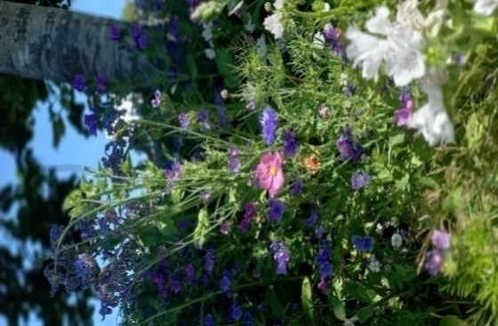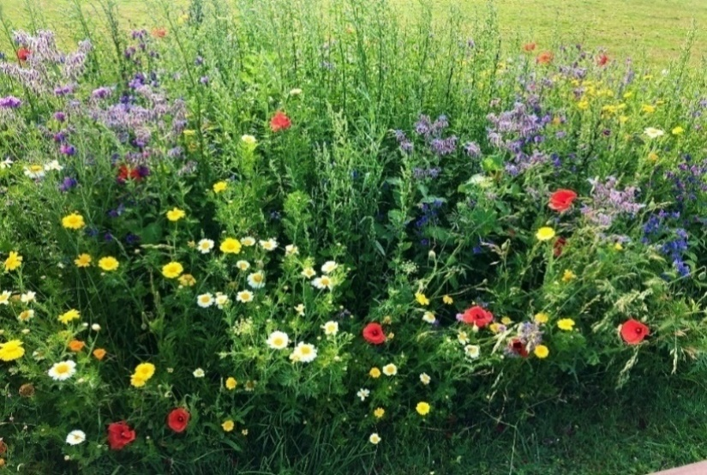

|  |  |
| --- | --- |
| Dawn Reid – **Assistant Clerk to the Council** | 2nd August 2022 |

Committee appreciated that due to the current hot weather and dry spell, the wildflowers presently did not look at their best.

Committee thanked the Assistant Clerk for her report and AGREED this item is complete and can be removed from the Agenda.

**706/22 EAST PRESTON VILLAGE GREEN – 8b) To receive any update on the application to hold the Sundowners Street Food Event on the Village Green.**

The committee NOTED the following paper which had been circulated in advance of the meeting:

Jon Nutley applied to hold a Sundowners event on the Village Green on 22nd July, from 5pm – 10pm. The application and paperwork were circulated electronically to committee, for its consideration. Committee agreed the event could take place subject to Councillor McElroy approving all the paperwork.

Councillor McElroy requested the Risk Assessment document should be updated and advised Jon, due to the sale of alcohol at the event, a SIA (Security Industry Association) trained personnel is required.

Jon provided copies of his updated Risk Assessment and event plan, which were agreed by Councillor McElroy. There were a few issues with the appointed SIA personnel’s ID document but these were promptly delt with.

I met Jon the day prior to the event to go through the site plan and protocol. The event ran smoothly and it was quite well attended. Feedback from public was, the event was not well advertised and neighbouring residents said they had not been informed it was taking place. I have included this in my feedback to Jon and added the following to the council’s event procedure: Provide leaflet/advertising flyer to PC Office, for electronic distribution to neighbouring properties.

In reflection, the lateness of receiving documents to allow Councillor McElroy time to approve, was concerning. Committee may wish to discuss adding a time scale to the events procedure stating when all documents need to be received and approved by.

Dawn Reid – **Assistant** **Clerk to the Council** 26th July 2022

Committee thanked the Assistant Clerk for her report. Councillor McElroy reiterated the lateness of receiving documents was concerning and the timing when documents should be received and agreed by, needed to be specific and stated on the event application form. A discussion took place and committee AGREED that all documents should be received and agreed three months prior to the event date. Committee asked the Assistant Clerk to make the changes to the application procedure and send to Councillor’s Wilkinson and McElroy to review and approve.

**707/22 EAST PRESTON VILLAGE GREEN CAR PARK – 9a) To receive any updates on the Village Green Parking**

**scheme.**

The committee NOTED the following paper which had been circulated in advance of the meeting:

The revenue the council has received from the car park ticket machine, from April to July 2022, is £741.37. In comparison the same period in 2021, was £877.61.

**Committee is asked to note the car park revenue from April to July 2022 was £741.37.**

Committee received the following request from Cloud 9, regarding an annual parking permit for the Village Green Car Park:

Cloud 9 asked if committee would consider allowing it to purchase an annual parking permit, to park its vehicles in the car park. This would alleviate vehicles from being parked on the road side and hopefully contribute to better relationships with businesses in the village.

For information, if a vehicle was parked in the car park for 5 days a week, for 52 weeks, the cost would be approximately £1300.00.

The Clerk also received correspondence from Councillor Paul Kelly on parking, which was circulated to Council. Councillor Kelly had received a complaint about the parking in East Preston. Councillor Kelly said *“I have noticed that the car park in EP seems to be mostly empty during the day when I have passed by and vehicles struggling to find a parking space in the village. Do you think it worth pursuing a parking permit system for the car park, for people who work or live in the village?*

*A 1,2 or 3 monthly permit would take the inconvenience of having to find the correct change for the machine each day and the loss of any fee paid should they have to leave early. It may even open up more parking spaces for shoppers using the EP shops and bring in more revenue for EPPC.*

*I know that One Parking can supply the permits for you to dispense because we use that system at the Conservative hall. Just an idea a thought might be worth pursuing,*

*Regards*

*Paul Kelly*

*The Clerk responded to Councillor Kelly thanking him for his suggestion and informed him:*

*‘the council has considered this a couple of times before.*

*As you will be aware, the car-park is very small, only 16 spaces. For a parking permit to be attractive enough for people to purchase, this council believes there must be a pretty good guarantee you will have a parking space when you want one, that’s what you have paid for after all. That would seem to suggest the maximum number of permits the council could issue would be 16. 16 people out of a population of 6,000 would result in a very exclusive car-park. We think that would run the risk of the car-park being empty a lot more often and possibly a number of complaints about not being able to use the car-park because bays are not available. Alternative: make half the spaces permit-only – that still runs the risk of half of the car-park being empty most of the time. Also, disgruntlement from visitors, and it is visitors who are generally happy to use the car-park because they do not see anything wrong with paying to park’.*

*Whilst additional income is not to be sniffed at, income was never the main reason behind introducing charging in the car-park. Charging was introduced because the council was receiving complaints from residents and some businesses that other businesses were dominating the car-park, both daytime and, different businesses, in the evenings. As income was not a primary consideration, the council set the hourly rate for the car-park at just 50p. A question we have asked on occasion but never received an answer to, is why will residents not pay just 50p an hour, why would they rather park inconsiderately and, in some cases, illegally, repeatedly?*

*We would be interested to know what we can learn from the Conservative Hall experience, although the situations appear quite different, the Conservative Hall car-park not being open to the public.*

District Cllr Kelly replied to the Clerk as follows, “I fully understand the council’s dilemma and remember when the car park was free how some people monopolised it by parking a van in there all night and using the same space to park a car in all day so a space was available for their van when they had finished work. However, I think there are new comers to the village who look at an empty car park and don't understand why people are parking, as you say, illegally instead. Perhaps a small letter in the village magazine explaining the problem, like the letter you sent me, may solve the problem for a while. There is no problem at the hall any more as far as parking goes as we work a permit system that is free to us and hirers not to the village.”

**Committee is asked to consider a request from Cloud 9 to purchase an annual parking permit.**

Dawn Reid – **Assistant** **Clerk to the Council** 2nd August 2022

In a separate matter, the Clerk was contacted by a resident who felt she had received a parking fine unjustly. This was on a day when the council had been informed the machine was not taking cash and had put a sign on the machine to that effect. The sign did not advise people they still needed to pay, using the app, and this will not happen again. Initially, Simon asked the resident to challenge the ticket, which she duly did, but her appeal was rejected. When informed of this, Simon asked the Chairman of the Council if he would agree to the council getting the fine cancelled, which he did. The last time the council had cancelled a fine, it had cost us £30; on this occasion it cost us £50 because of the number of days which had passed since the fine had been issued. I am currently seeking clarification from One Parking Solutions as to whether or not they can suspend issuing fines when the machine is out of order as they seem to be a number of residents who remain reluctant to download “yet another app” or who do not have the right sort of phone. They have been willing to pay cash into the office, but we have, so far, not allowed anyone to do so. If we can get One Parking to agree to suspend visits when the machine is broken, they will still get income from people paying by the app, but it would mean the council could say to anyone offering to pay cash that we would not take their cash and they would be safe from being fined.

Simon Cross – **Clerk to the Council** 2nd August 2022

Councillor Toney asked if there was any reason why the revenue had dropped in the same period as the previous year. The Assistant Clerk advised there was nothing apparent for this, the previous year was post pandemic so it could just be that more people were back out and using the facility.

Committee NOTED the revenue received from the car park ticket machine was £877.60. Committee asked the Assistant Clerk to monitor the revenue and report back at the next meeting.

Committee thanked Cloud 9 for its correspondence regarding an annual parking permit for the Village Green car park.

A discussion took place and concerns were raised, the car park could become personal parking for businesses. Committee felt given there are only sixteen parking spaces available, one of which is a disabled parking bay, this could cause problems with the car park being full of business vehicles and there would then be no available spaces for visitors and residents to park.

Councillor McElroy believed this was the reason why the fifty pence parking charge had been introduced.

Committee voted and AGREED not to issue any annual parking permits and asked the Assistant Clerk to inform Cloud 9 of its

decision on this matter.

Committee thanked Councillor Kelly for his correspondence on this matter. The Clerk advised committee he has responded to Councillor Kelly, as in his report.

Committee thanked the Clerk for his report regarding the resident who felt she had received a parking fine unjustly, and noted the council had on this occasion agreed to have the fine cancelled. Committee will wait for further updates when OPS has clarified if it can suspend issuing fines when the ticket machine is reported as out of order.

**708/22 EAST PRESTON VILLAGE GREEN CAR PARK – 9b) To receive an update on the Automatic Number Plate Recognition System (ANPRS).**

The committee NOTED the following paper which had been circulated in advance of the meeting:

Enerveo completed installation of the Mini Feeder Pillar and electric connection on 15th June 2022. I have informed Gavin, One Parking Solution (OPS), the final stage of the work is complete. As requested by Councillor McElroy I asked Gavin if the ANPRS can be set to recognise vehicles register as disabled, which are tax exempt with DVLA. Gavin responded ‘‘What can we do it maybe have a singular ANPR camera on the disabled bay, so they get the 3 hours free parking for that bay’? This information was circulated electronically for committee’s consideration.

Councillor Wilkinson enquired ‘if there would be any further cost to the Parish Council if it agreed to follow Gavin’s proposal?  If not, I suggest we accept it. If there is an additional cost we will need to discuss further and hopefully reach a consensus’.

I have contacted Gavin several times asking him to confirm who will pay for the additional camera, to the date of writing this report Gavin response.

|  |  |
| --- | --- |
| Dawn Reid – **Assistant Clerk to the Council** | 1st August 2022 |

The Assistant Clerk advised that she has emailed Gavin, OPS, again and is still waiting for a response confirming who will pay for the additional camera to monitor the disabled parking bay.

A discussion lengthy discussion took place regarding the camera would only being able to check a disabled vehicle registered with the DVLA and not the person with the disability, as the badge system does. Committee felt if this is the case it is fairer to charge everyone for parking in the Village Green car park.

Committee voted and AGREED to charge for the disabled parking in the Village Green car park.

The Assistant Clerk with inform Gavin, OPS, of the decision. Committee asked the Assistant Clerk to remind OPS to amend the car park signage accordingly and ensure the fifteen minutes grace period was included as it appears not to be prominent on the current signage.

**709/22 BANK AT THE JUNCTION OF LASHMAR ROAD AND NORTH LANE 10a) To receive an update on**

**clearing the bank area at the south-western corner of Lashmar Road**

The committee NOTED the following paper which had been circulated in advance of the meeting:

The second planter has been delivered directly to Ferring Nurseries, Courtenay is arranging for its installation and adding seasonal flower planting. I have arranged a meeting with Garry, Tivoli at Lashmar Bank on Wednesday 3rd August 2022, to discuss the grass turfing and what he suggests for the area moving forward.

|  |  |  |
| --- | --- | --- |
| Dawn Reid – Assistant Clerk to the Council |  | 26th July 2022 |

The Assistant Clerk advised she is waiting for Tivoli’s quote for grass seeding or turfing the area around the planters. This will be circulated electronically to committee for its consideration. If committee decide to go ahead, this work would not take place until the weather is suitable. Committee thanked the Assistant Clerk for her update and will await Tivoli’s quote.

**710/22 TO CONSIDER ANY TREE MATTER RELATING TO THE VILLAGE – 11a) To receive any update on the request to remove the London Plane Tree adjacent to the Cricket Club House and the proposal to install a double bay net facility.**

The committee NOTED there were no further updates on this item at the time of writing the report.

There are no further updates on this item at the time of writing this report.

Dawn Reid – **Assistant Clerk to the Council** 27th July 2022

The Assistant Clerk advised committee, she had received an email from Mr Dallimore that morning saying ‘Currently we are

awaiting a quote to improve the single practice net, which may be a way forward’

Committee noted Mr Dallimore’ s response and will await further updates.

**711/22 TO CONSIDER ANY TREE MATTER RELATING TO THE VILLAGE – 11b) To consider a replacement tree for the David Quick memorial tree.**

The committee NOTED the following paper which had been circulated in advance of the meeting:

At the previous meeting committee requested seeking expert advice, on planting another tree in the same position as the deceased tree and if it was advisable to plant a tree of the same species.

Phil Arnott, ArbTec Tree Care, the Council’s Annual Tree inspector said, “In my experience, most new tree establishment issues are caused by either poor planting or lack of after care. If there are no visible signs of disease etc, I would have thought re-planting in the close vicinity should be fine”.

Committee may recall this tree was planted just prior to when COVID and the first lockdown began, therefore this may have caused disruption to the watering programme.

**Committee is asked to consider planting a replacement tree for the David Quick memorial tree, at Two Acres.**

Dawn Reid – **Assistant** **Clerk to the Council** 15th June 2022

The Assistant Clerk informed committee in Agenda item 18a: Correspondence. The Clerk had received correspondence from ADC regarding its 100 Trees for Parishes Project. ADC is commitment to tackling climate change, and is donating one hundred plus free trees, to each Town & Parish Council within the district. Trees include up to one hundred ‘whips’ comprising a native hedgerow mix 60% hawthorn and 5 other species. The other 5 variable species are usually made up of Blackthorn, Field maple, Dogwood, Crab apple, Guelder Rose, Dog Rose and Hazel. There is also up to three bareroot three-metre-tall ‘standard’ native trees, a choice of any three, from Oak, Field Maple, Rowan, Hawthorn and Lime.

Committee thanked the Assistant Clerk for this information and AGREED if suitable to use one of the scheme’s trees, to replace theDavid Quick memorial tree.

The Assistant Clerk advised that ADC’s deadline to receive orders, is the first week of December and asked if two committee members would be willing to assess suitable locations to plant the trees. Councillor’s Wilkinson and McElroy offered to assist with this.

**712/22 TO CONSIDER ANY TREE MATTER RELATING TO THE VILLAGE – 11c) To receive information on the Millennium Yew Tree at Warren Recreation Ground.**

The committee NOTED the following paper which had been circulated in advance of the meeting:

Tom, The Urban Surgeons, has carried out the work on the Millennium Yew Tree, at WRG. Tom was able to remove the invasive elm tree from the centre of the Yew, but was unable to get enough of the roots out without causing damage to the Yew, therefore it could not be replanted.

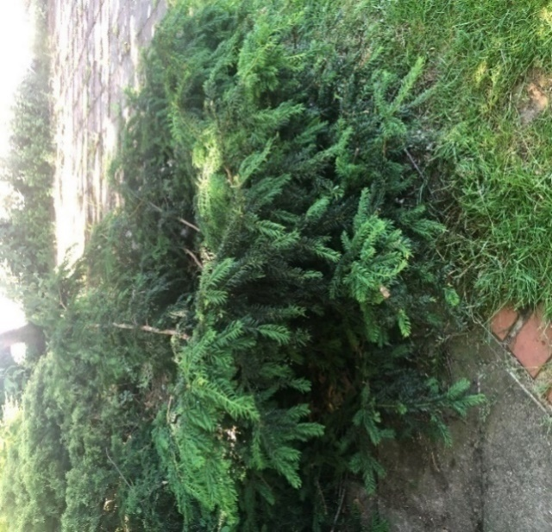

I asked Tom for advice on aftercare, if the Yew tree should be supported, given its spreading form. Tom advised ‘The *Yew tree has already taken a bit of a strange form unfortunately! And there's not really anything I could suggest to change that at the moment really. Maybe a bit of formative pruning would help in time but I would personally leave it for the moment’.*

As previously reported there is no commemorative plaque marking the Millennium Yew tree, nor is this tree listed on the Annual Tree Inspection report.

The Clerk informed Margaret Gilbert, who had originally highlighted the Yew Trees existence to Council, that the Elm tree had successfully been removed. Margaret kindly responded given an insight to the Yew Trees background:

*Dear Simon*

*Thank you for your update on, and photograph of, the Millennium Yew Tree in the Warren Recreation Ground.  
I am pleased that the tree consultant was able to remove the invasive elm sapling.*

*I have had a look at it,as you suggested. I cannot see any trace of the elm.It seems to be flourishing in its spreading form.*

*I have revisited its background.*

*The Church of England,partnered by Conservation Foundation, distributed thousands of yew tree saplings across England to every Parish Council that requested one. The project had two aims - to take cuttings from yew trees that were around 2000 years old, representing a link with Christianity, and for them to be a living symbol for another 2000 years brought about by their local environment being cared for and cherished.*

*Our Parish Council applied for a sapling. As a Council member, I volunteered to attend Evensong at Chichester Cathedral Sunday 3rd October 1999 at a special presentation of these Millennium Yews. “The Yew Tree Hymn”, specially composed, was sung. Afterwards we gathered behind the cathedral where the saplings were laid out and, after their blessing, we were invited to take one. There was a rush to get them and I finished up with a rather poor specimen.*

*The oldest yews are often in churchyards. Given the background to this project, the saplings tended to be planted in churchyards. Local examples are at Angmering and Poling. The then vicar of St. Mary’s, however, declined it. I was asked to look after it, which I did for several years, eventually handing it over to the Council.*

*I gave the Council the accompanying documentation. Unfortunately, I understood, this went missing. I recollect it came from an ancient churchyard yew in Hampshire. My 2018 book “The Immortal Yew” lists 3 Hampshire churchyards with ancient yews - at Itchen Abbas, West Tisted, Arlesford and at Lockerley, but I couldn’t now say if it came from one of these. The Parish Council monthly meeting took place on 4th October 1999 so I would have reported on my attendance. The minutes might help.*

*There has been a revival of interest in this project and the progress of the saplings - “Are the Millennium Yews Casting their shade?” (Church Times referring to an article 17.10.2019 by Madeleine Davies). There is a Tree Register to report progress* [*info@treeregister.org*](mailto:info@treeregister.org)*.*

*There is a good summary of the project “Millennium Yews - Wikipedia”.*

*The choice of the paved area in the south east corner for its site is interesting. My understanding is that this corner is a memorial by the Cricket Club to the Crole-Rees father and son, who lived in Angmering Lane, and were strong supporters of the club in the years, at least to 1960, as Vice Presidents and the son serving as secretary and also being a player.*

*I have never seen a commemorative, or similar, plaque. It would be nice to have one.*

*Regards*

*Margaret*

**Committee is asked to acknowledge the correspondence received from Margaret Gilbert and to consider the request to install a commemorative plaque to mark the Yew trees existence.**

Dawn Reid – **Assistant** **Clerk to the Council** 21st June 2022

Committee thanked Margaret Gilbert for her correspondence and the interesting background as to the Yew Trees existence. Committee voted and AGREED to placing a memorial plaque at the Yew Tree, providing the Cricket Club agree with its location.

**713/22 TO CONSIDER ANY TREE MATTER RELATING TO THE VILLAGE – 11d) To receive any update on the June Phillips tree application.**

The committee NOTED the following paper which had been circulated in advance of the meeting:

The application was circulated electronically to committee for its consideration. Committee voted and agreed to grant the application, and choice of tree, either a Hornbeam Magnifica or Rowan Sheerwater, planted at the western end of Two Acres, on the right-hand grass area.

I have informed Mrs Phillips of committee’s decision and that planting would take place, anytime between November 2022 and February 2023.

Dawn Reid – **Assistant** **Clerk to the Council** 21st June 2022

The Assistant Clerk advised committee, Mrs Phillips is very happy to hear the tree application had been granted.

Committee thanked the Assistant Clerk for her update and NOTED the progress on the tree application to date.

**714/22 TO CONSIDER ANY TREE MATTER RELATING TO THE VILLAGE – 11e) To receive information on the 2022 Annual Tree Inspection.**

The committee NOTED the following paper which had been circulated in advance of the meeting:

I contacted Phil Arnott, ArbTec Tree Care regarding scheduling in the 2022 Annual Tree Inspection. The 2021 inspection had taken place in September, therefore Phil advised, ‘it will be a winter inspection this year, possibly in December’. Phil said “a December survey would show the trees in their winter form etc”

I also asked Phil to add the newly planted trees at the Village Green and Two Acres, to the annual tree inspection.

Phil has quoted £420.00 +VAT to carry out a visual inspection of all of the Parish Council tree stock, at the named sites and to provide a written summary, highlighting priority remedial work where required.

**Committee is asked to consider the quote from ArbTec, for the 2022 Annual Tree Inspection**

Dawn Reid – **Assistant** **Clerk to the Council** 20th July 2022

The Assistant Clerk informed committee for comparison, the 2021 Annual Tree Inspection had cost £395.00.

Committee voted and AGREED, to accept ArbTec Tree Care’s quote of £420.00 +VAT, to carry out a visual inspection of all

of the Parish Council tree stock.

**715/22 WARREN RECREATION GROUND – 12a) To receive any update on the installation of lighting, at the north boundary of the car park.**

The committee NOTED the following paper which had been circulated in advance of the meeting:

Committee is still waiting for the quote from Enerveo for the work to extend the electrics from the Village Hall to the car park and install the lighting columns. I have contacted Simon Francis, Enerveo, on numerous occasions to find out when we are likely to receive the quote.

To the date of writing this report I have had no further responses form Enerveo.

At the May meeting, Councillor McElroy informed committee he was looking at an application he to Sussex Police and Crime Commission, for a grant for the car park lighting. The grant is to tackle community safety.

Dawn Reid – Assistant **Clerk to the Council**  2nd August 2022

The Assistant Clerk advised committee she had still not received the quote form Enerveo for the lighting installation.

Committee acknowledged Enerveo are extremely busy at the moment, hence the delay.

Councillor McElroy updated committee, the deadline for the Sussex Police and Crime Commission grant application had been too tight and further grants will be coming up shortly, which he will apply for.

Committee thanked Councillor McElroy and look forward to hearing when the next round of grants will be.

**716/22 WARREN RECREATION GROUND – 12b) To receive any updates on the Children’s Playground**

The committee NOTED the following paper which had been circulated in advance of the meeting:

The 2022 ROSPA Safety Inspection has been completed and the report received. Councillor Wilkinson and myself have reviewed the report and it appears there are no major actions required. All findings and actions have been marked as low risk. The report indicates some wear on the bushes of the Junior swings, some exposed decking on the Multi-play equipment, dry bearings and re-painting to the Carousel Turnstile. I have contacted Duncan, Playsafe Playgrounds, to quote for the annual service to the Spinmee inclusive roundabout and also asked him to quote for the additional work highlighted on the report. A copy of the report is available at the council office, should any committee member wish to review it.

Dawn Reid – Assistant **Clerk to the Council**  18th July 2022

The Assistant Clerk updated committee she had received the quote from Playsafe Playgrounds Ltd, of £331.00 +VAT for the annual service to the Spinmee Inclusive Roundabout.

Committee voted and AGREED to accept the quote of £331.00 +VAT and go ahead with the annual service to the Spinmee

Inclusive Roundabout.

The Assistant Clerk advised Playsafe Playgrounds Ltd, provided a second quote for the recommendation work highlighted in the ROSPA report. The quote was for £1,264.00 and the work included: Junior swings - replace all shackles and bushes and lubricate on assembly. Multiplay unit - Sand back exposed deck edges and apply 2 x sealant coats. Infill 2 x finger traps on panel. Prepare, prime and repaint rusting sections of steelwork with 2 x coats machine enamel. Turnstile- Lubricate.

The Assistant Clerk informed committee in comparison the cost in 2021 for similar work was £882.00 inc VAT but this excluded the Junior Swings repairs, therefore the quote appeared reasonable.

Committee thanked the Assistant Clerk for her report. Committee voted and AGREED to accept Playsafe Playgrounds Ltd’s quote of £1,264.00+VAT, for the recommendation work as highlighted in the ROSPA report. Committee requested this work is completed at the same time as the Spinmee Inclusive Roundabout service.

**717/22 WARREN RECREATION GROUND – 12c) To receive any updates on a wheelchair accessible swing, at the children’s playground.**

The committee NOTED the following paper which had been circulated in advance of the meeting:

As agreed at the 16th May 2022 Amenities Meeting, Councillor Wilkinson met on site with Councillor Linton, to discuss the suitability of Warren Recreation Ground to locate the proposed Play Panels. Unfortunately, Councillor McElroy was unable to attend the site meeting.

Councillor Wilkinson reported, ‘on 27th July 2022, Councillor Linton and I met at the Rec to discuss the installation of play panels instead of a disability swing. We looked at the Rec as a whole and decided that the ideal location for the four panels would be alongside the footpath running on the eastern boundary of the rec from the car park to the turn where the footpath is adjacent to the northern boundary.

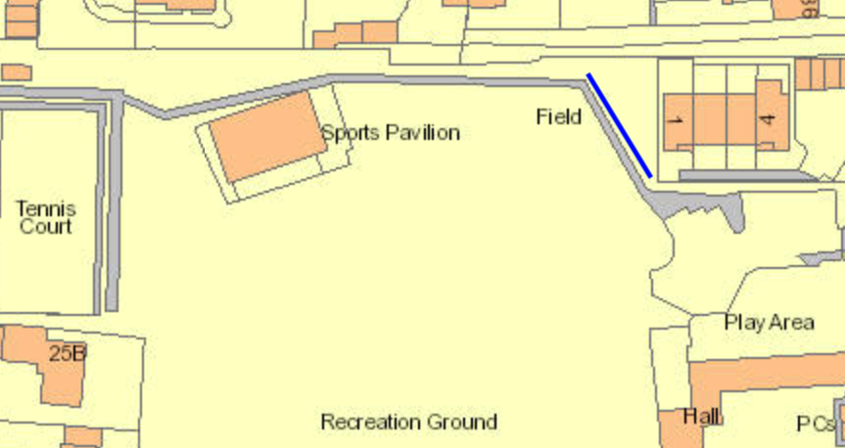 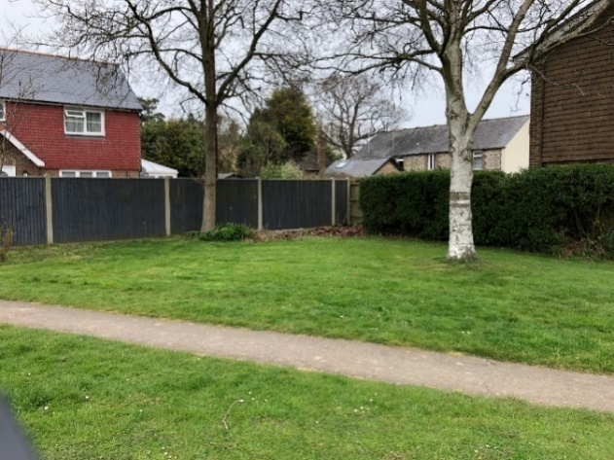

This suggested location would require the footpath to be made wider and levelled, to allow better access.

I have contacted three companies asking for a quote for this work, two of which are from the WSCC list of approved contractors. If committee decides to move forward with installing the play panels, I would suggest the work to widen the footpath is done first and then the panels installed.

Dawn Reid – **Assistant Clerk to the Council**  27th July 2022

Councillor McElroy apologised to committee for being unable to attend the site meeting, with Councillor Wilkinson and Linton, to assess the suitable locations to install any play panels.

Councillor Linton updated committee the suggested location is alongside the tarmac footpath running on the eastern boundary of the rec, from the car park to the turn where the footpath is adjacent to the northern boundary. Councillor Linton said committee may wish to consider how may panels it would like to install should it go ahead.

The Assistant Clerk updated committee she met with TT Driveways Ltd, to discuss widening the tarmac footpath. TT Driveways Ltd will quote for widening the footpath to two meters. The Assistant Clerk will circulate the quote to committee electronically for its consideration.

The Assistant Clerk brought to committee’s attention Agenda item 18a: Correspondence. Correspondence has been received from Mr Paul Ammo, East Preston Film Society, regarding donating an Outdoor Chess Table to the village. This information had been circulated electronically to committee prior to the meeting. Mr Ammo had provided images of the Outdoor Chess Table and expressed the favoured location would be Warren Recreation Ground.

Committee thanked Mr Amoo for his correspondence and the Film Society for its kind offer to donate an Outdoor Chess Table to the Village.

Committee voted and unanimously AGREED, to accept the donation of the Outdoor Chess Table from EP Film Society.

Committee also favoured the suggested location of the North Eastern corner of the Warren Recreation Ground as it would sit well alongside any play panels. The Clerk advised committee will need to discuss the proposal and agreed it with the Cricket Club.

**718/22 WARREN RECREATION GROUND – 12d) To receive an update on the trees along the western boundary at the Warren Recreation Ground.**

The committee NOTED the following paper which had been circulated in advance of the meeting:

At the May meeting, Committee agreed to go ahead with ArbTec’s recommendation, to reduce the trees heavily back to the same height and then closely monitor. Tom, The Urban Surgeons has provided the following quote to carry out the work:



Tom advised ‘my preference would be Summer in terms of being able to access the field with minimal damage, it also makes sense to do it before winter and potentially strong winds from a health and safety perspective’.

**Committee is asked to consider the quote from The Urban Surgeons, to reduce the height of the western trees at Warren Recreation Ground.**

Dawn Reid – **Assistant Clerk to the Council**  21st July 2022

The Assistant Clerk reminded committee, following recent tree work at Warren Recreation Ground, The Urban Surgeons, had raised concerns about the western boundary trees. The Assistant Clerk also sought advice on these trees from ArbTec Tree Care, who also agreed the best way forward was to reduced heavily to the same height and closely monitor.

Committee thanked The Urban Surgeon and ArbTec Tree Care, for their advice on the western boundary trees. Committee voted and AGREED to accept The Urban Surgeons quote of £3,475.00+VAT to reduce the height of the trees at the western boundary of Warren Recreation Ground. The Assistant Clerk will consult with the Cricket Club when was the best time is to carry out the work.

**719/22 PUBLIC SEATING – 13a) To receive any updates on Public Seating around the village.**

The committee NOTED the following paper which had been circulated in advance of the meeting:

As part of the ongoing maintenance programme, regular work is carried out on the benches around the village. Priority work at the moment is the ‘Happy to Chat’ benches, which are Council owned benches, these have several slats requiring replacing.

Dawn Reid – **Assistant Clerk to the Council**  27th April 2022

The Assistant Clerk advised committee she had been unable to source recycled plastic slats to fit the ‘Happy to Chat’ benches. The cost to replace several of the broken oak slats would be in the region of £300.00. The Assistant Clerk advised Glasdon UK, have the Lowther Bench which is very similar and in recycled plastic, costing £574.34 excluding VAT.

The Assistant Clerk will circulate the information on the Lowther bench electronically to committee for its consideration.

The Assistant Clerk reminded committee it had already allocated £400 per year over a five-year period to refurbish benches. If budget allows committee may wish to consider replacing the ‘Happy to Chat’ benches this year and then consider replacing the other two benches by the chip shop next year.

Committee thanked the Assistant Clerk for her report and will await further information for its consideration.

**720/22 PUBLIC SEATING – 13b) To receive any update on Mrs Walters bench donation application.**

The committee NOTED the following paper which had been circulated in advance of the meeting:

The concrete base was installed on 24th May 2022 as planned and the bench was then installed on 2nd June 2022. Mrs Walters has said she is planning to visit and try out the new bench.

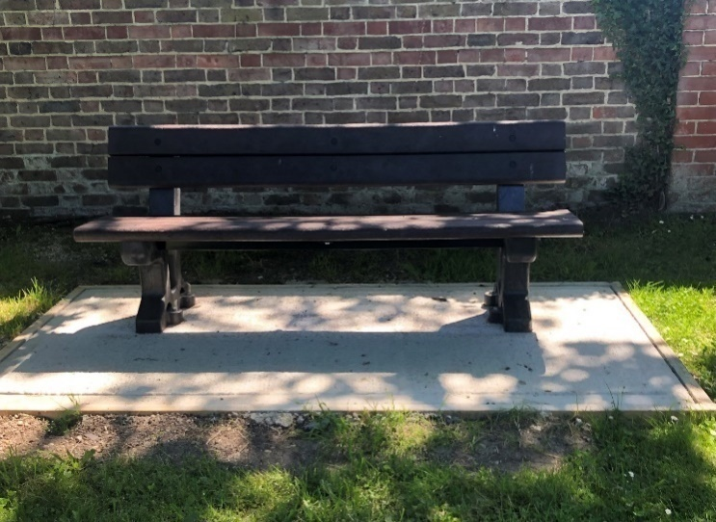

|  |  |
| --- | --- |
| Dawn Reid – **Assistant Clerk to the Council** | 9th June 2022 |

The Assistant Clerk advised committee, the installation of Mrs Waters bench is complete and that Mrs Waters is happy with the end result. Committee AGREED this item is complete and can be removed from the Agenda.

**721/22 PUBLIC SEATING –** **13c) To receive any update on the Peter and Lorna Dyer memorial bench application.**

The committee NOTED the following paper which had been circulated in advance of the meeting:

Mrs Dyer submitted an application form requesting to place a memorial bench at the western side of Warren Recreation Ground. The bench is in memory of Peter and Lorna Dyer. The bench would be placed to the south of the Derek Russell bench and the bench style is the Elwood seat, which is exactly the same as the Derek Russell bench. The Cricket Club has been consulted and has no objections to the proposed location of the bench.

The application was circulated electronically to committee, for its consideration. Committee voted and agreed to allow the memorial bench at Warren Recreation Ground.

I have informed Mrs Dyer of committee’s decision and am currently making the necessary arrangements for the construction of the concrete base.

|  |  |  |
| --- | --- | --- |
| Dawn Reid – **Assistant Clerk to the Council** |  | 9th July 2022 |

The Assistant Clerk updated committee she is waiting for the Hand man’s quote for constructing the concrete base. The bench has been ordered and delivery time is usually around six weeks. Committee thanked the Assistant Clerk for her update.

**722/22 TWO ACRES –14a) To receive any update on relocating the Wildflower Beds.**

The committee NOTED the following paper which had been circulated in advance of the meeting:

On 28th July 2022, I met with members of EP in Bloom at Two Acres, to discuss the proposal of a preparing a bed and planting shrubs on the grass area at the western end of Two Acres. Committee suggested Mrs Phillips’s tree could be planted at the centre of the bed.

Group members suggested creating an oval shaped bed, measuring approximately 3mtrs x 6mtrs. The bed would require digging out and a membrane and bark chippings being laid. I have asked Tivoli to quote for the preparation work.

The group would then look at planting suitable shrubs. The tree would ideally need to be planted first and allowed to become establish before beginning work on the bed.

|  |  |
| --- | --- |
| Dawn Reid – **Assistant Clerk to the Council** | 28th July 2022 |

Committee thanked East Preston in Bloom for its proposal for the bed at the western end of Two Acres. Committee will wait to receive the quote from Tivoli for the work to prepare the bed before reaching its decision.

**723/22 SEA ROAD ISLAND – 15a) To receive any information on installing planters at the Island in Sea Road.**

The committee NOTED the following paper which had been circulated in advance of the meeting:

The order has been placed for the five interlocking planters. Tim, Plantscape, has advised, ‘At present we are waiting for materials for building these to come in which will probably mean we are looking at 4 – 6 weeks for delivery’.

I spoke to Courtenay, Ferring Nurseries regarding a quote for the installing and the initial floral display. There was some discussion on if the planters should be secured to the ground, Courtenay advised not to secure the planters to the ground, if they were hit by vehicle they would continue to move, thus causing the least damage to the planter and vehicle.

I asked Simon Neville, WSCC, for further advice on regulations for fixing the planters. Simon advised, ‘We do not have any guidance for this specific task. However, we would anticipate that the planters would be affixed to the ground, as benches and bins are, for example. I would suggest that you speak with a contractor as they will be able to advise the best way of doing this’. The contractor carrying out this work would require £10million Public Liability Insurance and New Roads and Street Works accreditation.

I also contacted the Council’s Insurance Company for its advice regarding cover and was advise

‘Neither we nor the insurers have any requirements around the fixing planters to the ground, it is not something we can comment on as we do not have the expertise to advise on this. The insurers generally ask that reasonable care is taken when undertaking something new and that it is risk assessed’.

Tim, Plantscape, advised ‘the thinner planters I would fix down using a resin anchor bolt and we can provide a bracket for this to fix to. He said ‘I think in 30 years I can remember one occasion of a planter tipping, so it’s not something that is a regular occurrence.

I have asked Tim to supply fixing brackets for all the planters should committee decide to secure the planters to the ground.

To the date of writing this report I am waiting for confirmation on the expected delivery date of the planters.

**Committee is asked to consider if the planters should be secured to the ground.**

|  |  |
| --- | --- |
| Dawn Reid – **Assistant** **Clerk to the Council** | 21st July 2022 |

Committee thanked the Assistant Clerk for her report. Committee AGREED to secure the planters to the ground.

The Clerk advised that Councillor Toney holds the New Roads and Street Works accreditation required by WSCC. If this is acceptable to WSCC, Councillor Toney could oversee the planter installation work. Committee thanked the Clerk and will wait for further updates on the installation.

**724/22 ELECTRIC VEHICLE CHARGE POINTS – 16a) To note an update on the provision of electric vehicle charge points in the village.**

The committee NOTED the following paper which had been circulated in advance of the meeting:

The council has submitted three suggested locations, the car parks at the Village Green, the Warren Recreation Ground and the East Preston & Kingston Village Hall and each had been visited by the WSCC/Connected Kerb team. Initial feedback was each site was probably too small for the programme.

Connected Kerb referred the Village Green and Warren Recreation Ground car-parks to Oyster, a company which installs a smaller number of rapid charging points, but it too has said the car-parks are too small. The Village Hall car-park application is now being handled by the Village Hall committee itself. There has been some confusion over the Connected Kerb “requirement” all charging point parking spaces are only for use by people charging their vehicles. I have said to have six spaces, the Connected Kerb minimum, made solely for use by charging vehicles would not be acceptable when we have so few spaces in both car-parks anyway.

Connected Kerb has recently come back with a proposal of phased parking spaces. This would seem to mean installing six charging points into a car-park, three of which would immediately only be for use by electric vehicles, whilst the other three remain available for all vehicles. After 12 months, the idea would be to make all six spaces solely available for electric vehicles. **How does the committee feel about that suggestion?**

Connected Kerb, although initially talking about whether EPPC would be able to part-fund the installations in the Village Green and Warren Rec car-parks, has confirmed it could probably afford to install in the Village Green car-park as above. The Assistant Project Manager, Ben Smith, has said he will get back to us with a price for us helping an installation at the Warren Rec.

If we are not happy to proceed on the above phased understanding, Connected Kerb will mark East Preston Parish Council sites as unfeasible.

Connected Kerb has spoken to the Village Hall directly and marked the site as unfeasible owing to the infrastructure expenditure believed necessary.

|  |  |
| --- | --- |
| Simon Cross – **Clerk to the Council** | 2nd August 2022 |

A lengthy discussion took place regarding the type of charging point and the percentage of income the Parish Council would receive. The Clerk advised the charging points are fast charges but not super-fast charge, as in supermarkets. The income goes across county and a percentage would be divided and distributed across councils.

Councillor Gale did not think the current demand for electric charging points warranted taking up six parking spaces in the small car parks in the village. Councillor Bradshaw advised at this time, he was against progressing with the installation of the charging points.

Committee voted and AGREED, it is not ready to progress at this stage. Committee asked the Clerk to contact Connected Kerb, to enquire if it will come back to the council again towards the end of the project.

**725/22 BUDGETS – a) To note** **the 2022/23 Income and Expenditure for the Amenities Committee and the Warren**

**Recreation Ground Trust to date.**

Committee thanked Mrs Khoo for providing the 2022-23 budget papers to date, for the Amenities Committee and the Warren Recreation Ground Trust.

Committee NOTED that the WRG Trust – Major Works budget, is showing a credit balance of £2K+ due to receiving the insurance pay-out for the vandalised Unisex Toilet Door, and the work to replace it has not yet been completed.

**726/22 CORRESPONDENCE**

The Committee NOTED the following paper which had been circulated in advance of the meeting:

Committee received the following correspondence from EP in Bloom, outlining its proposal for the Northern Shops flower beds:

*‘At our last EP in Bloom meeting the group discussed the difficulty in adding plants to the large flower bed at the northern shops. The problem is that the roots of the large tree are so impacted they prevent any further planting.  In addition, the roots are pushing the membrane up. The group have asked if the Amenities Committee would consider the following:*

*Remove all plants, bulbs and planters*

*Remove membrane*

*Clear as much root as possible without damaging the tree*

*Relay new membrane*

*Replant area, seeking advice from Ferring Nurseries on a year-round planting scheme.*

*Add bark, as necessary.*

*The group would be happy to do the planting, but would need the assistance of either Ferring or Tivoli for the clearing process.*

*Flower Bed adjacent to the fish and chip shop. - We would like more bark for this area.  Is it possible for this to be delivered and laid by Ferring/Tivoli as necessary.*

I met with members of the group at the Northern shops, to discuss the difficulties mentioned above. The soil is very compact and the large tree roots are clearly visible, but there appears to be a problem with compacted smaller roots, which could be coming from the tree, or maybe from years of bulbs root growth from the daffodils.

I have contacted Tom, The Urban Surgeon for his advice, Tom said “I must admit I'm not comfortable with the idea of removing roots of live trees, as it could affect their health and stability”. Tom said he will carry out a site visit to get a better idea of the problem and try to assess the feasibility.

I have also asked Tivoli to quote for removing some of the compacted soil, retaining the flower bulbs to reuse and relaying a membrane and bark chippings, as suggested by group members.

|  |  |
| --- | --- |
| Dawn Reid – **Assistant Clerk to the Council** | 28th July 2022 |

Committee thanked EP in Bloom for its correspondence and outlining its proposal for the Northern Shops flower bed.

The Assistant Clerk advised committee she has not yet received Tivoli’s quote for the suggested work on the Northern Shops flower bed. The Assistant Clerk will circulate the quote electronically to committee for its consideration.

A discussion took place and committee AGREED to wait to receive Tivoli’s quote, before reaching its decision.

Committee NOTED the following paper which had been circulated in advance of the meeting:

The Clerk received the following correspondence from Mr Nigel White, asking committee to consider a request to install a Dog Bin in Manor Road.

*Dear Mr Cross*

*I have a maisonette in The Crescent in Manor Road. The Crescent consists of 3 blocks of 4 maisonettes with a common green space behind a large hedge which abuts Manor Road and car parking spaces.*

*The residents have been suffering for some time from Dog walkers who toss used dog poo bags over the hedge and into the green space and on occasions even into the rear gardens.  Nobody has spotted the culprit(s).*

*I was therefore wondering if it might be possible for the Council to install a poo bin in Manor Road not necessarily on the Angmering on Sea Estate but somewhere between The Crescent and Sea Road.*

*Hopefully this would make it easier for Dog walkers to dispose of their waste in a more responsible manner.*

*Yours sincerely*

*Nigel White*

The Clerk and I walked along Manor Road to look for a suitable place for the dog waste bin. Not wanting to place a dog waste bin immediately outside someone’s property, the options are at the entrance to the greenspace on the northern side between the entrance to Nursery Close and Sea Road. Or to place one on the bit of land that holds The Crescent’s street sign, at the entrance to the estate.

**Committee is asked to consider the request to place a dog waste bin in Manor Road.**

|  |  |
| --- | --- |
| Dawn Reid – **Assistant Clerk to the Council** | 19th July 2022 |

Councillor Bradshaw declared a personal interest in the next Agenda item and abstained from any discussions.

Committee thanked Mr White for his correspondence regarding installing a Dog Bin in Manor Road.

The Clerk updated committee that Mr White has approached the estate to discuss his request. The Clerk advised committee to await an update on the response before considering the request further.

The Assistant Clerk advised Committee, correspondence has been received from Mr Roy Allen, regarding the large Holm Oak tree at the southern end of the Village Green. Mr Allen has asked for to be reduced in size. The tree is less than three metres away from Mr Allen’s property. The Assistant Clerk informed committee she has asked Tom, The Urban Surgeon, to advise and quote for any necessary work. This information will be circulated electronically for committee’s consideration.

The Assistant Clerk reminded Committee of the correspondence received from EP in Bloom on weed control. EP in Bloom has produced a draft weed killing protocol document, which was circulated electronically to committee prior to this meeting and asked committee for its thoughts on weed control in the village.

Committee thanked EP in Bloom for sight of its weed killing protocol document. The Chairman will respond accordingly once all committee’s members views have been received.

**727/22 URGENT MATTERS ARISING (FOR INFORMATION ONLY)**

Prior to the meeting, the Assistant Clerk had circulated to committee members confirmation the East Preston & Kingston Horticultural Society, could proceed to hold its Annual Flower Show on Saturday 7th August 2022, at Warren Recreation Ground.

**728/22 ITEMS TO BE REFERRED TO THE NEXT AMENITIES AGENDA**

To consider an offer from the Lawn Tennis Association to implement a free-of-charge booking system for the Warren Recreation Ground tennis court.

The date of the next meeting is 14th November 2022.

**The meeting concluded at 20.45 hrs.**

Chairman: S Wilkinson Date: 23rd August 2022